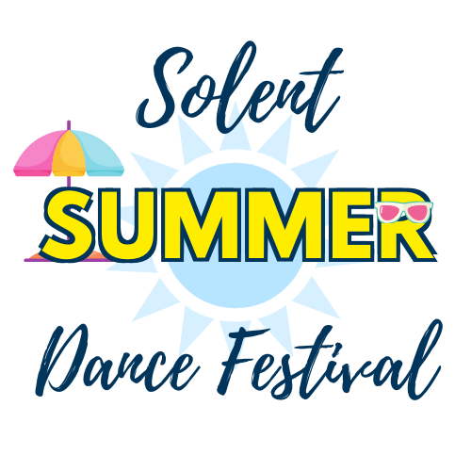

SOLENT SUMMER DANCE FESTIVAL
DANCE TEACHER AGREEMENT FORM

I authorise ……………………………………………….…………. from …………………………………………………………….………
to take part in Solent Summer Dance Festival as an independent entry and give consent for them to use material that has been choreographed by either myself or another authorised teacher within the school.

I wish for the dance school name to be affiliated with this pupil and give consent for it to be acknowledged in any social media, programme or award ceremony

I do not wish for the dance school name to be affiliated with this pupil and do not give consent for it to be acknowledged in any social media, programme or award ceremony

Signed …………………………………………………………………………………………………
Print Name …………………………………………………………………..................................
Date …………………………………………………………………………………………………….
Dance School …………………………………………………………………………………………
Position in school …………………………………………………………………………………….

